EMPOWER – Client User Documentation

Contents

Controls 2

Setup/Install 2

Standalone 2

Installer 2

Starting the Client 3

Splash/Menu/New Game 4

Splash 4

New Game 4

Menu 4

Map Screen 5

Controls 5

Screen Layout 5

Game Progression 6

Location/Events 6

Screen Layout 6

Actions/Character Cards 7

Screen Layout 7

Consequence Cards 7

Screen Layout 7

Information Cards 8

Screen Layout 8

Character Screen 9

Screen Layout 9

Diary Screen 10

Screen Layout 10

Cards Screen 11

Screen Layout 11

# Controls

Left Click/Tap – Accept/Select/Drag Map

# Setup/Install

## Standalone

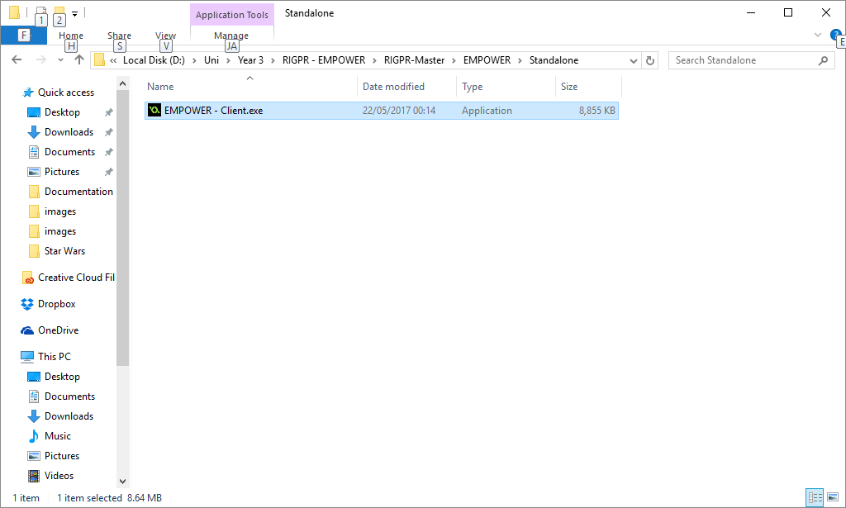If you are using the standalone exe, simply double click the icon to open the application.

## Installer

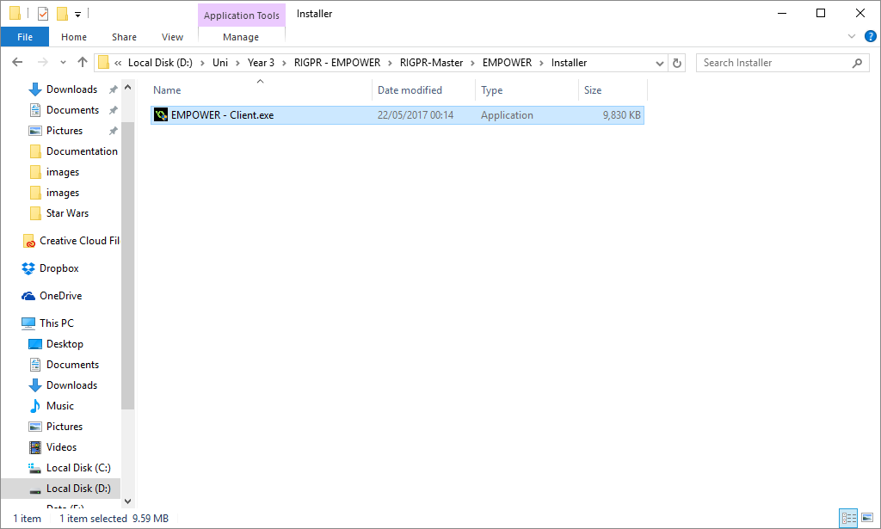If you are using the installer, double click the icon and you will be presented with the install window, this will require you to agree to the License Agreement and select an install location; other options such as start menu and desktop shortcuts are also offered. If you follow the prompts from the installation window, it should explain what is required at each step.

Once the process has completed, select the shortcut (either start menu or desktop, if you selected this option) or navigate to the install location and double click the icon to begin.

# Starting the Client

* 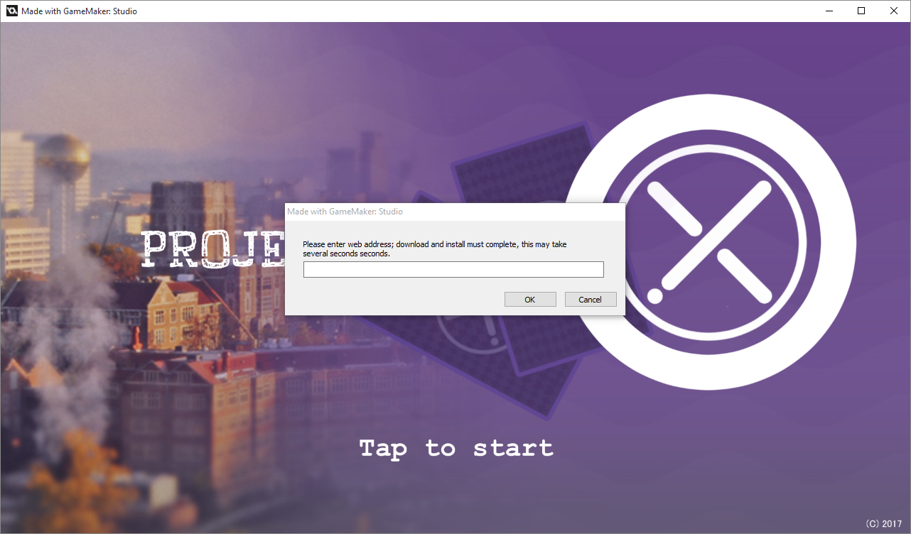When you first start the client, you will be presented with a window asking for a web address; this should have been provided to you.
* 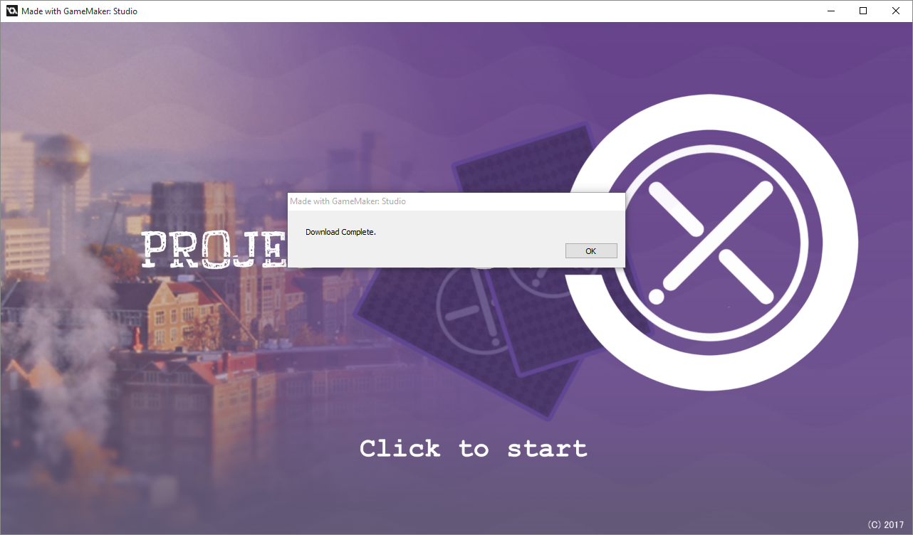Once you have entered the address, click Ok. If the address is correct and the download/install process is successful, you will be given a message to inform you of this. Click OK to the message to continue.
* If there are any issues with the address, it will present you with the attempted address where you can resolve any potential errors.

# Splash/Menu/New Game

## Splash

* Once the download process has complete, you will start on the splash screen, simply click/tap to continue.

## New Game

* If this is your first time playing, you are required to enter your name.
* Once you have filled out your Name, you have two options, you can either “Continue” (viewing the tutorial) or “Skip Tutorial” (skipping the tutorial).
* If you do not skip the tutorial, you MUST complete it (or start a new game and skip) otherwise you will not be able to continue, if you get half way through and exit, it will restart the next time you continue.

## Menu

1. Continue – If you are returning, you can click this button to continue the game from where you left off.
2. New Game – This will completely clear all progress and restart the game.
3. Options – PC only, here you can Toggle full-screen and reset the window sizes if necessary.
4. Credits – If you wish to see information about who created the game, you can click here for some info.

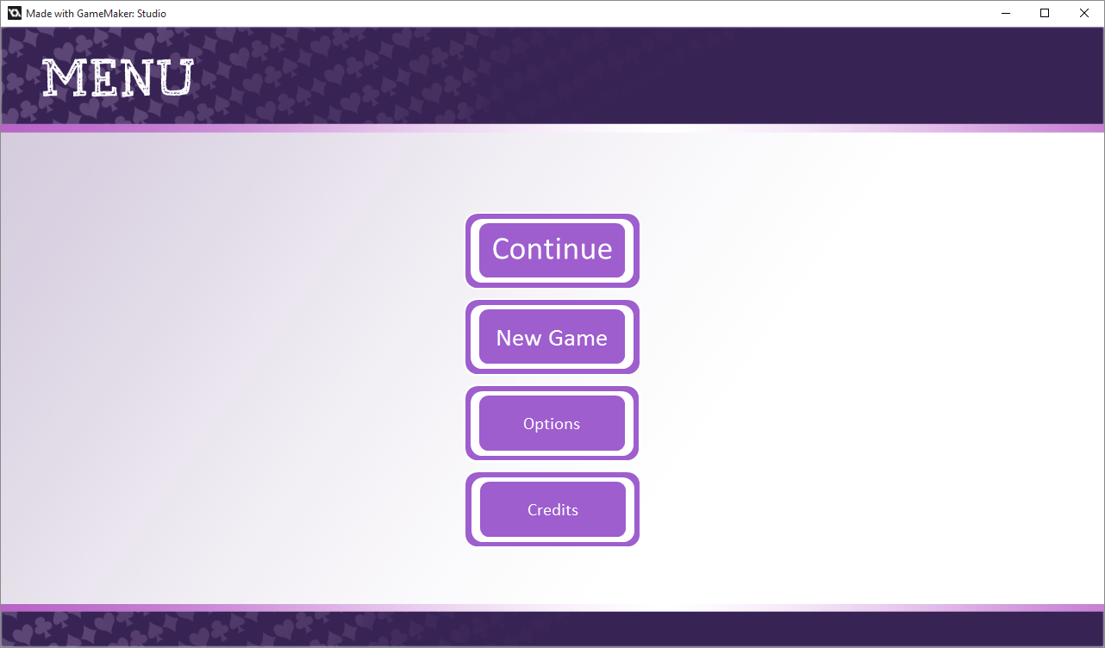

4.

3.

2.

1.

# Map Screen

## Controls

* Tap/Left Mouse Button – Accept/Select/Drag Map
* Two fingers – Pinch screen/Scroll Wheel Up – Zoom In
* Two fingers - expand fingers/Scroll Wheel Down – Zoom Out

On the Map Screen, you can use the Left Mouse Button or Tap (on mobile) to select buttons displayed on the screen. Clicking and holding the button on the Maps background, will allow you to drag the mouse and move the map.

On PC, you can use the scroll wheel to zoom in/out.

On mobile, you can use two fingers and pinch/expand your fingers to zoom in/out.

## Screen Layout

1. Location – On any week, there can be Locations that hold events, selecting these will allow you to open the Location and select events from the list.
2. The current Week/Year is displayed here.
3. This button will take you to the Character Screen, from here you can see your stats view previously selected Locations/Events and view your collected Cards.

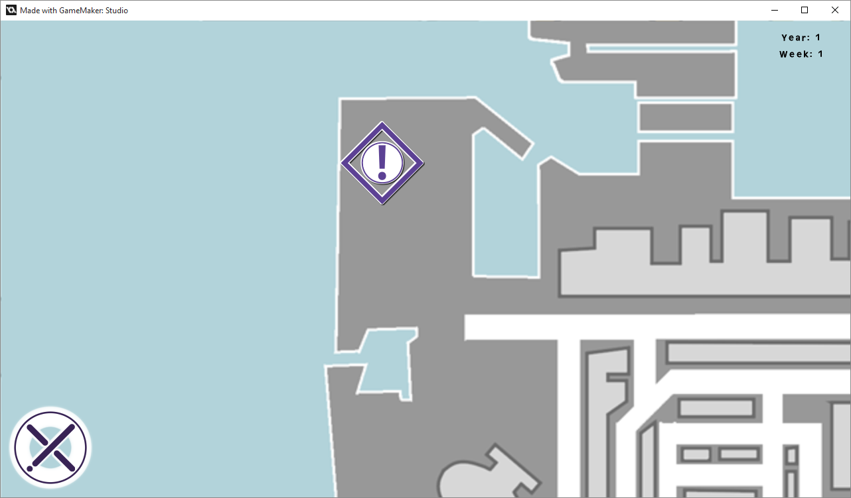

2.

1.

3.

# Game Progression

After clicking a Location on the Map Screen, the game will progress as follows.

## Location/Events

### Screen Layout

1. Location Name
2. Location Description
3. Back button – This button will take you back to the previous screen when selected, you can go back at any time.

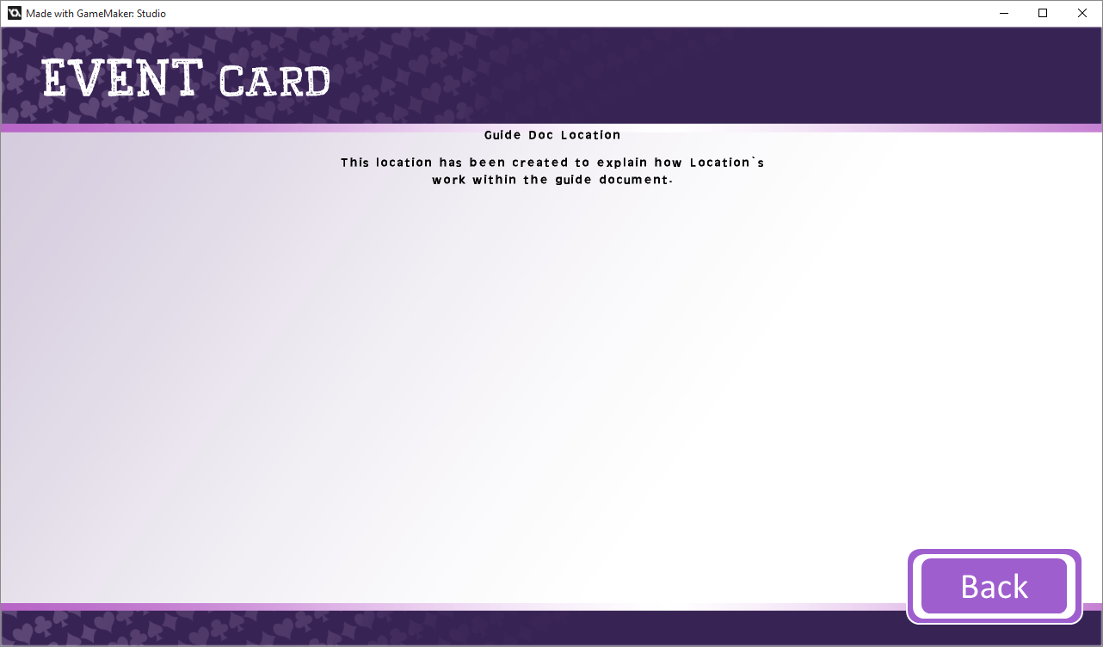

1.

2.

3.

4.

1. Clicking anywhere within this screen will display the available Events at this Location.
2. An Event Card that can be selected to view the Actions attached to the Event.
   1. When the Event Card is selected, you will be taken to the next screen.

6.

1. Card stats – Each Card will have a display of either text info about the card, required stats or stat changes as a result of that card.

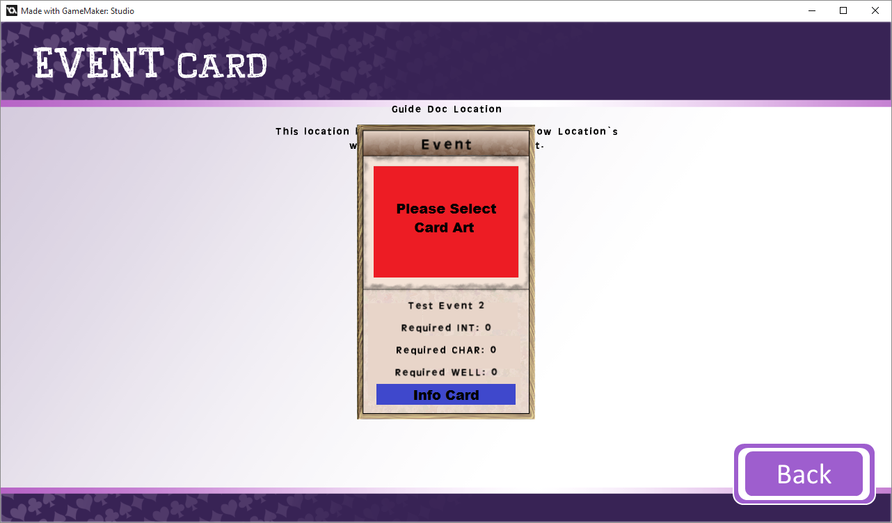

5.

## Actions/Character Cards

### Screen Layout

1. Available Action Cards – the available Action Cards will be displayed here.
2. Character Card – Some events will have a Character attached, these can be collected by selecting them.

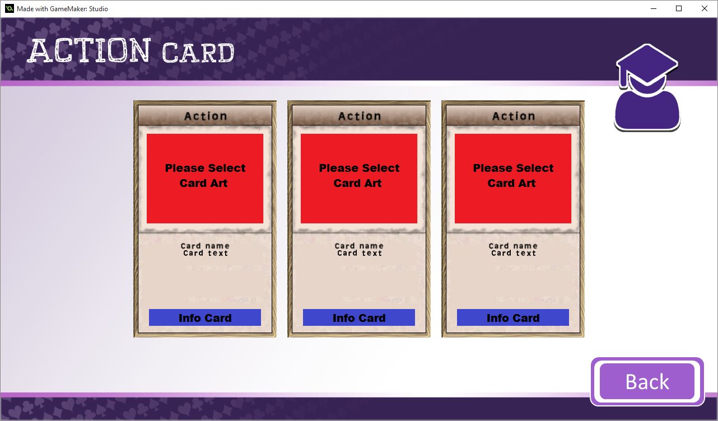

2.

1.

## Consequence Cards

### Screen Layout

1. Consequence Card – Clicking this will accept the consequence and all previous Cards, registering them to your History. The week will advance by 1 and you will be presented with new Locations to select.
2. Info Card – On all cards there is an attached Info Card, selecting this will display the card and info alongside each other.

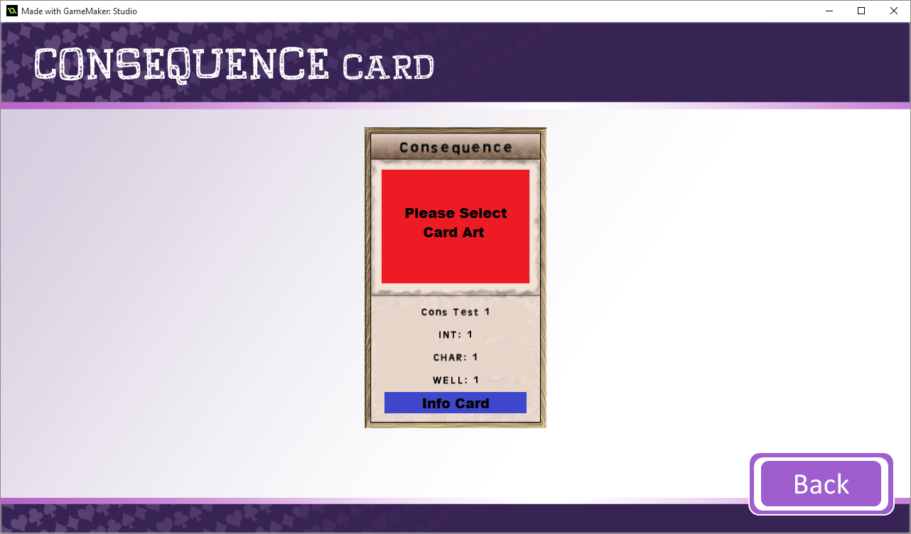

1.

2.

## Information Cards

### Screen Layout

1. Card – This is the card which you selected to view the Info Card for.
2. Information Card – This is the attached Information Card
   1. Clicking the Info Card section here, will open the web address linked to this card.

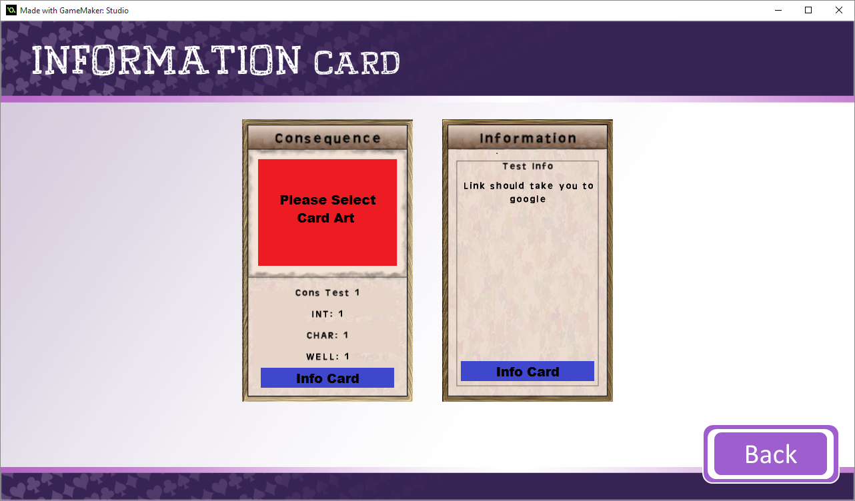

2a.

1.

2.

# Character Screen

## Screen Layout

1. Your chosen name and current Stats.
2. Journal Screen button
3. Cards Screen button.

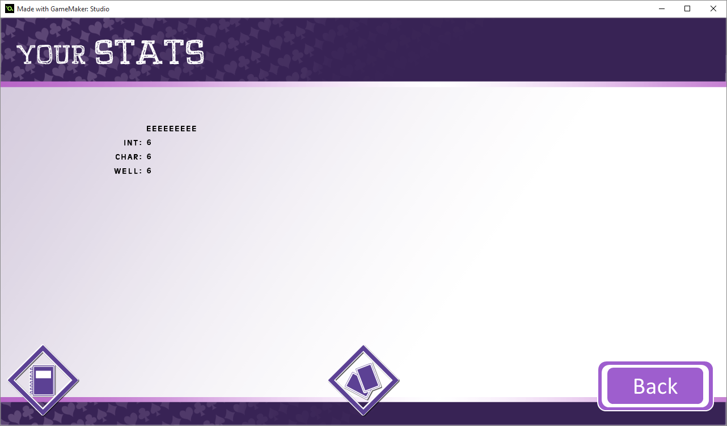

3.

2.

1.

# Journal Screen

## Screen Layout

1. Journal Entry Info
   1. Location’s Name
   2. Old and New Stats
2. Journal Entry text box – Text can be entered here regarding the entry.
3. Event Card selected
4. Action/Character Card selected
5. Current Week/Year that you are viewing, arrows can be used to advance the week/year.
6. Retry Event – If you wish to retry the event, choosing new events/actions, clicking this button will begin the process.

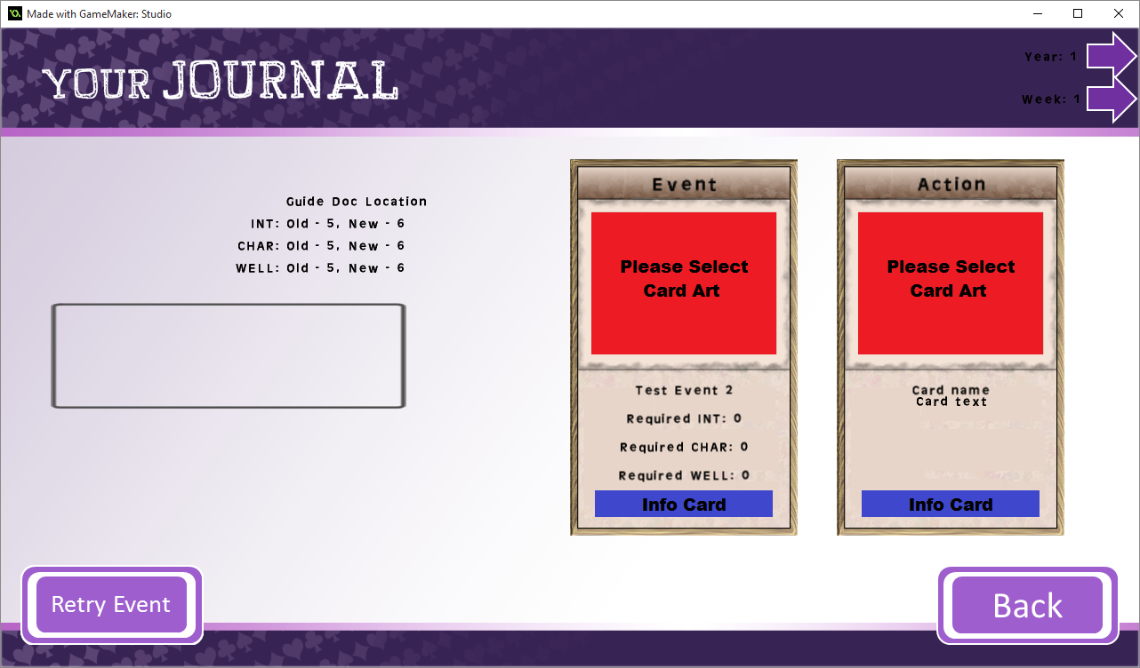

6.

5. 

4. 

3. 

2.

1.

# Cards Screen

## Screen Layout

1. Card List – The cards you have collected will be displayed here.
2. Change Card View – This will swap the card view between the currently display (selection of cards) and an alternate display (list of cards).
3. Change Card Type
   1. This button will swap between Card Types.
   2. The current Card type will be displayed at the top and bottom
4. If there are more cards than can be fit on screen, arrows will appear to enabled progression through the list.

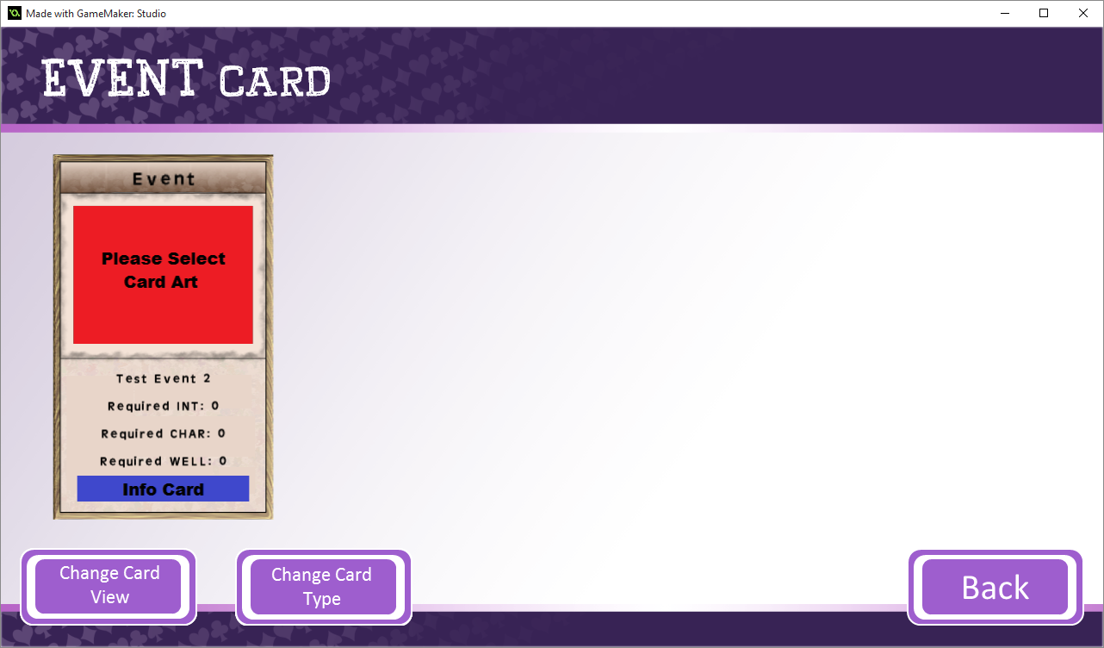

2.

3a.

3b.

1.